Project Bloom: A Quest for Home

By Renegadeware

**LO:**ESS2.D-1

Weather and Climate - Weather and Climate Factors

**Things I liked:**

* Game has great visuals that illustrate the learning objective in a clear and digestible manner
* Gameplay mechanics were intuitive and connects the gameplay to learning objective well
* The learning objective being evenly dispersed throughout gameplay will hold player’s attention

**LO issues:**

* While it does feel like the game covers a reasonable amount of main concepts for the learning objective, a small portion of that feels like the information has to be interpreted by the player when looking at the maps such as:
  + **Ocean currents transfer thermal energy between the equator and polar regions of the globe.**
  + **The Coriolis effect deflects atmospheric and oceanic currents, which affects regional climates.**
  + Which is okay for the game’s overall purpose, but I’ll make a note about it so you are aware in case you were expecting the game to be more direct with it

**Gameplay Issues:**

* Would be beneficial in the beginning of the game for the game to somehow point or draw the player’s attention to the location it is referring to. Not all players will have a firm grasp on general geography to know where the game is talking about: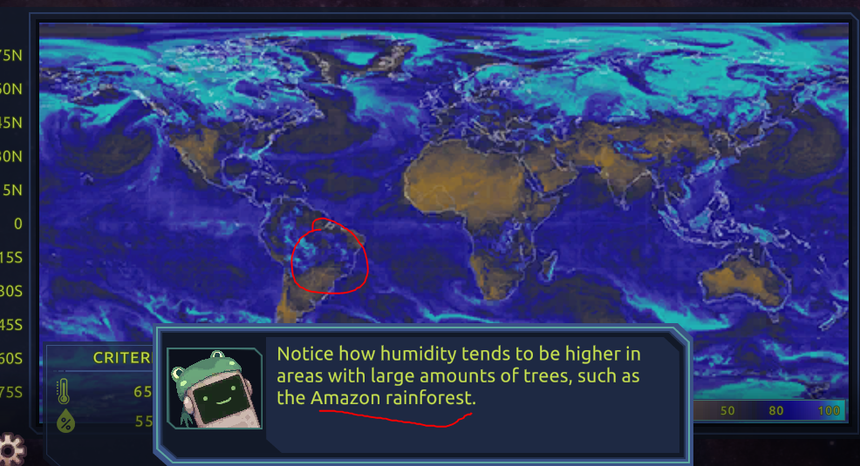
* These numbers would have more clarity if they were labeled. It took me a moment to understand what this was trying to tell me. The left side is what the area is providing and the right side is the range or parameters for which the frogs will be okay with: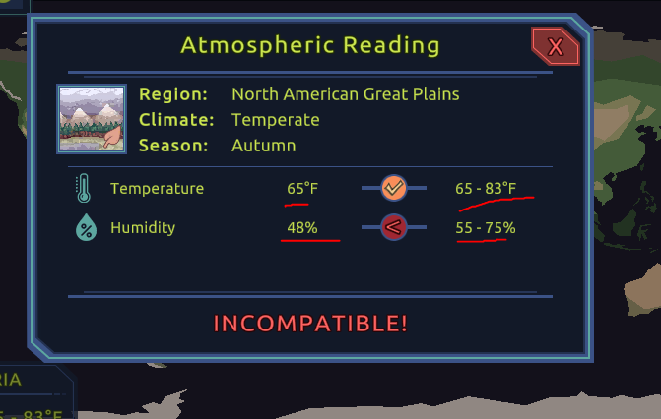

**Bugs:**

* *No bugs detected*.